Paul Satchell

CIS 355

Individual Project

Design Documentation

Screen Flow Diagram



Database Diagram

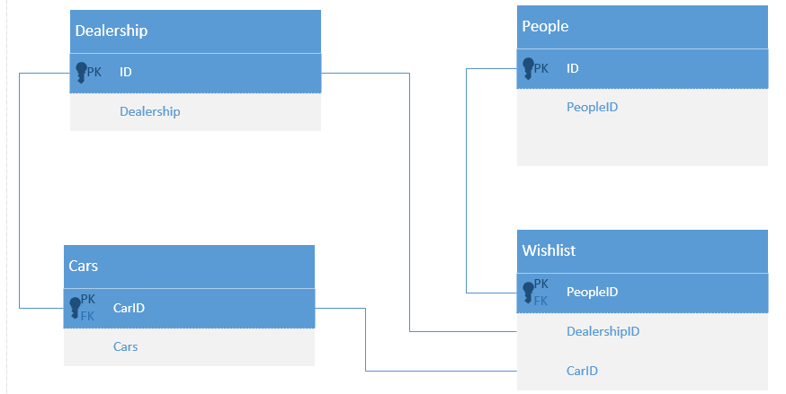

Database Schema

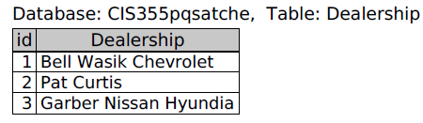

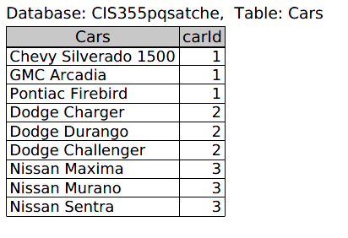

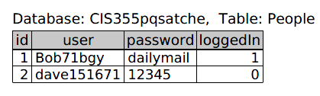

Flowchart



This system is designed to allow users to create login credentials, view local auto dealerships and their respective inventories, and add vehicles to a wish list.

This system is useful because users get to scan all their local dealerships at once and receive up to the minute information. Only the dealerships managers will be granted a username and password and can update after each sale. It also allows the user to store cars in a wish list for easy viewing.

The system is a handy tool for anyone searching for a vehicle. It will probably mostly be used at home, in the office, and at participating dealerships.

This site will be hosted on the SVSU server. I chose this because I don’t have a way to host it from home. This is a better solution because traffic shouldn’t be an issue.

I used phpMyAdmin, Notepad++, and Putty to complete this project.

I chose this project because shopping for cars is a hassle.

Username -> username

Password -> password

Use Case Diagrams

